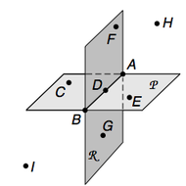

- Use the above figure to answer the following questions.

  - What is the intersection of plane P and plane R?
Plane P and Plane R intersect along the line in the middle: Line AB.

  - Name three points that are collinear
"Co-linear" means "on the same line: So, A, D and B

  - Name plane R in two more ways
FDG or FAG

  - Name four coplanar points
"Co-planar" means "on the same plane": So, A, B, C, D (or F, D, B, G) (or A, D, B, E)

  - Name a point that lies on both plane P and plane R
Point A

- To the nearest tenth, find the perimeter of ∆ABC with vertices A (-1,4), B(-2,1) and C(2,1). Show your work.
A= (-1, 4) = (xa, ya) →xa=-1, ya=4
B= (-2, 1) = (xb, yb) →xb=-2, yb=1
C= (2, 1) = (xc, yc) →xc=2, yc=1

Perimeter of ∆ABC: P=AB+BC+AC

AB=d A-B=sqrt [(xb-xa) ^2+ (yb-ya) ^2]
AB=sqrt [(-2-(-1)) ^2+ (1-4) ^2]
AB=sqrt [(-2+1) ^2+ (-3) ^2]
AB=sqrt [(-1) ^2+9]
AB=sqrt [1+9]
AB=sqrt [10]
AB=3.162277660

BC=d B-C=sqrt [(xc-xb) ^2+ (yc-yb) ^2]
BC=sqrt [(2-(-2)) ^2+ (1-1) ^2]
BC=sqrt [(2+2) ^2+ (0) ^2]
BC=sqrt [(4) ^2+0]
BC=sqrt [16+0]
BC=sqrt [16]
BC=4

AC=d A-C=sqrt [(xc-xa) ^2+ (yc-ya) ^2]
AC=sqrt [(2-(-1)) ^2+ (1-4) ^2]
AC=sqrt [(2+1) ^2+ (-3) ^2]
AC=sqrt [(3) ^2+9]
AC=sqrt [9+9]
AC=sqrt [9*2]
AC=sqrt [9] * sqrt [2]
AC=3 sqrt [2]
AC=3 (1.414213562)
AC=4.242640686

P=AB+BC+AC
P=3.162277660+4+4.242640686
P=11.40491834
To the nearest tenth:
Perimeter P=11.4

- Use the figure to complete each statement. 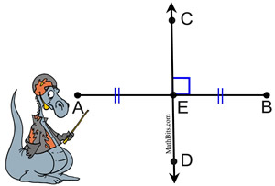
  - m<BED = 90
  - CD is the perpendicular bisector of AB
  - AE = ½ AB (AE = EB)
  - If AB = 18, then EB = 18/2 = 9
  - E is the midpoint of AB

- If AB = 58, find the value of x. Show your work.

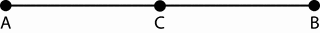
3x - 6 2x + 4
3x-6+2x+4=58
=>5x-2=58
=>5x=58+2
=>5x=60
=>x=60/5
=>x=12

- Write a conditional statement. Write the converse, inverse and contrapositive for your statement and determine the truth value of each. If a statement’s truth value is false, give a counterexample.
Conditional Statement: If it is a Datsun, it is a car.
Converse: If it is a car, it is a Datsun. This is a false statement, since a car can be any other type (ex. Mercedes).
Inverse: If it is not a Datsun, it is not a car. Again a false statement, since if it is a different type, it is a car despite not being a Datsun. For example, it could be a Mercedes
Contrapositive: If it not a car, it is not a Datsun. This is true, since if something is not a car, it won't be any particular type of car either (and it won't be a Datsun).

- Name two pairs of congruent angles and justify your answer.

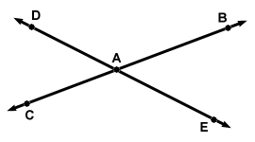
<DAB & <CAE are congruent because they are vertical to each other
<DAC &<BAE are congruent because they are vertical of each other

- Write a two-column proof
Given: `
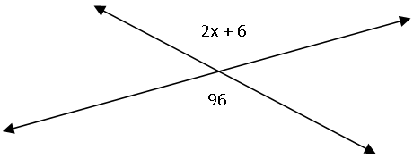
Prove: x = 45
The two angles, 2x + 6 and 96 are opposite angles.
Opposite angles are equal, so
2x + 6 = 96
2x = 96 - 6
2x = 90
x = 90÷2
x= 45
- Find the measure of the third angle of a triangle given that the first two angles are 44º and 72 º. Show your work.
Angles in a triangle add up to 180
Therefore 44+72+ x =180, where x is the third angle
X= 180-44-72
X= 64

- Write a congruence statement for the pair of triangles

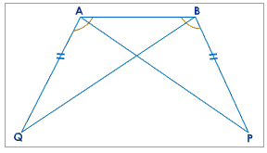
ΔABP is congruent to ΔBAQ
ΔABP ≡ ΔBAQ

- Find the values of x and y. Show your work.
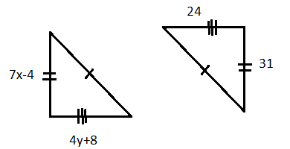
The two triangles are congruent and therefore
7x-4 = 31
7x= 35
X= 35/7
X= 5

4y+8= 24
4y=24-8
4y=16
Y=16/4
Y=4
- Which postulate or theorem, if any, could be used to prove the triangles congruent? If not enough information is given, write not enough information.

- 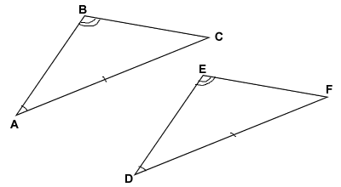

- 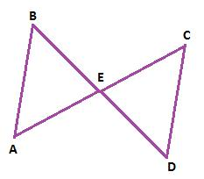

- 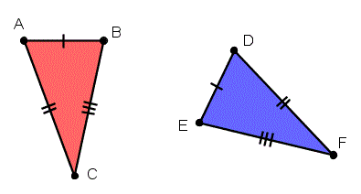

- 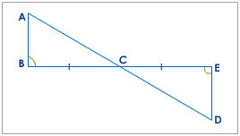

a) We are given side AC equals to side DF, angle ABC equals to angle DEF, and angle BAC equals to angle EDF
We have enough information to deduce that triangle ABC congruent to triangle DEF by postulate Angle-Side-Angle (ASA)
b) We do not have enough information
c) We are given side AB equal to side ED, side BC equals to side EF, and side AC equals to side DF
We have enough information to deduce that triangle ABC and triangle DEF congruent by postulate Side-Side-Side (SSS)
d) We are given side BC equals to side CE and angle CBA equals to angle CED
We also know that angle ACB equals to angle ECD are equal (opposite angles properties)
We have enough information to deduce that triangle ABC and triangle CDE are equal by postulate Angle-Side-Angle (ASA

- List the sides of each triangle from shortest to greatest
In every triangle, the largest side, is opposite the largest angle.
Also, the smallest side, is opposite the smallest angle.
  - 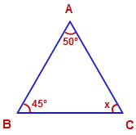
We start by finding <BAC = 180-45-50
= 85
Arranging the sides from the smallest we have
/AC/</BC/</AB/

  - 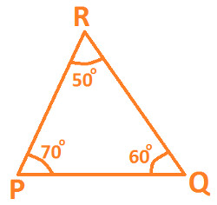

In this triangle the arrangement is as below
/ PQ/</PR/</RQ/
- If AB is the midsegment, find the value of x. Show your work.
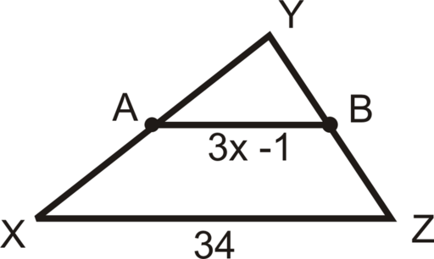
3x-1=34/2
3x-1=173x=17+1
3x=18/3, x=18/3, x=6

- Find the coordinates of the circumcenter for ∆DEF with coordinates D (1, 3) E (8, 3) and F (1,-5). Show your work.
The circumcenter has equal distance to each of the three vertices. Suppose the coordinates of the circumcenter O are (a, b). Then OD=\sqrt((a-1)^2+(b-3)^2), OE=\sqrt(a-8)^2+(b-3)^2), OF=\sqrt((a-1)^2+(b+5)^2).
Let OD=OE=OF, solve the equation.
x=9/2 = 4.5,
y=-1.
0 (4.5, -1).
- In triangle ∆PQR, C is the centroid.

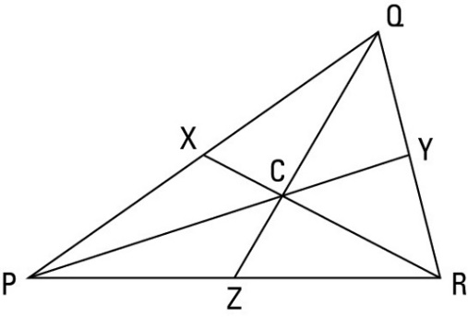

Given that C is the Centroid of the triangle PQR, it then follows that:
PZ = ZR ... (Equation 1)
QY = YR ... (Equation 2)
PX = XQ ... (Equation 3)
  - If PX = 25, find PQ
If PX = 25, find PQ
From the diagram, PQ = PX + XQ
Remember, PX = XQ ... (Equation 3)
Therefore, PQ = PX + XQ = PX + PX
⇒ PQ = PX + PX
PQ = 2(PX)
Since PX = 25
PQ - 2(25)
PQ = 50

b) If CY = 9, find PC and PY
We know that the centroid of a triangle divides each median into segments with a 2:1 ratio, therefore:
PC = 2(CY)
Since CY = 9,
PC = 2(9)
PC = 18
From the diagram, we see that,
PY = PC + CY
PC = 18, CY = 9
PY = 18 + 9
PY = 27

c) If QC = 12, find ZC and ZQ
Again, going by the fact that the centroid of a triangle divides each median into segments with a 2:1 ratio,
ZC = QC/2
Since QC = 12
ZC = 12/2
ZC = 6
From the diagram, we see that
ZQ = ZC + QC
ZC = 6, QC = 12
ZQ = 6 + 12
ZQ = 18
- For quadrilateral ABCD, determine the most precise name for it. A(-2,3), B (9,3), C(5,6) and D(2,6). Show your work and explain.
For this case, the first thing to do is to graph the ordered pairs given in the problem.
Then, join the points to see the quadrilateral formed.
In this case the quadrilateral is a trapezoid.
The trapezoid is a geometric figure with four sides, of which only two are parallel.
- For the parallelogram, find the value of the variables. Show your work.

5x + 2

3y - 6 21

17

In a parallelogram the opposite side are equal, that means
3y-6= 21
3y= 21+6
3y= 27
Y= 27/3
Y= 9
In the same way
5x+2= 17
5x=17-2
5x=15
X=15/3
X= 5

- What is the length of the 2nd base of a trapezoid if the length of one base is 27 and the length of the midsegment is 19? Show your work.
Assume that the second base is x
The mid-segment in a trapezoid is calculated as follows:
Mid-segment = (first base + second base) / 2
We have:
Mid-segment = 19
first base = 27
second base = x

Substitute in the equation and solve for x as follows:
Mid-segment = (first base + second base) / 2
19 = (27+x) / 2
19*2 = 27+x
38 = 27+x
x = 38 - 27
x = 11 units
- What is the sum of the measures of the exterior angles in a nonagon? Explain.
360 degrees. The sum of the measures of the exterior angles of any simple polygon is 360°. That is true for triangles, rectangles, pentagons, hexagons, a so on, any polygon including, of course, the nonagon.

- Find the measure of each interior angle AND each exterior angles of the following regular polygons. Show your work
  - A pentagon has five sides which forms 5 triangles. the central angle is equal to 360/5=72 degrees
The interior angle is equal to 2x
Angles in a triangle add up to 180, therefore 2x+72=180
2x=180-72
2x=108
Exterior angles =360/number of sides
=360/5
= 72

  - 16- gon
Interior angles: 2x
Number of triangles = 16
Central angle = 360 / 16 = 22.5°
Interior angle 2x, where 180° - 22.5° + x + x => 2x = 180° - 22.5° = 157.5°
Interior angle = 157.5°
Exterior angles: 360 / 16 = 22.5°
Exterior angles = 22.5°
  - Decagon
Number of sides 12
Central angle = 360° / 12 = 30°
Interior angle, 2x => 30 + 2x = 180 => 2x = 180 - 30 = 150°.
Interior angle = 150°
Exterior angle = 360° / number of sides = 360° / 12 = 30°
Exterior angle = 30°

